Ref: BAC/5119/21 Date: 07/09/2021

From
Office of the Principal
BhawanipurAnchalik College
Bhawanipur, Barpeta, Assam
PIN: 781352
Dated: Bhawanipur Anchalik College, the 7th September, 2021
To
All Admission Aspirants
Sub: Admission in Higher Secondary Second Year

NOTICE

Admission aspirants, for Admission in Higher Secondary Second Year (Arts), are hereby advised to take admission on or before 15/09/2021. You all are directed to see the Fee Structure and rules for admission and continuation of your study at Bhawanipur Anchalik College. All details have been documented in the Prospectus of 2021 – 2022 which is available in the College Web Portal, i.e. www.bacollege.ac.in. You are allowed to take admission as per Government Notification Ref. No: No: PC/HE/Misc./42/2O20/51, Dated Kahilipara the 6th September, 2021 from 11th September, 2021 onwards. No students will be allowed to continue classes without Admission.

This is for your information and early admission.

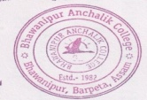
Yours faithfully
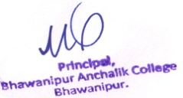
07/09/2021
Principal/Secretary
(Dr. Mukunda Sarma)
BhawanipurAnchalik College
Bhawanipur, Barpeta, Assam
PIN: 781352

